## Selecting Multiple Objects

Selecting multiple objects is useful when you want to move, duplicate, cut or copy more than one element on a plan. You will also need to select multiple objects if you wish to group a collection of items together.

Again, there are two ways to perform a multiple selection:

* By dragging a selection box around all of the elements (as described above).
* By holding **SHIFT** and repeatedly clicking on each element that you wish to select.

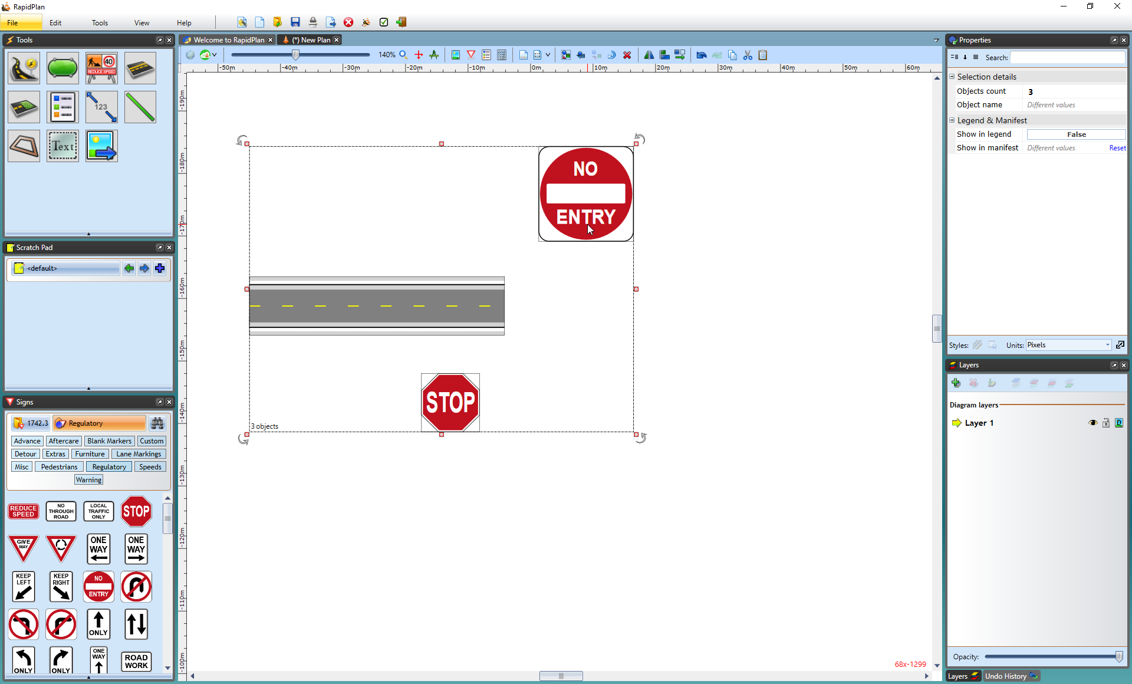

Multiple_objects_selected_with_SHIFT_key